REPUBLIC OF CAMEROON
PEACE-WORK-FATHERLAND
UNIVERSITY OF BUEA
FACULTY OF ENGINEERING AND TECHNOLOGY


TITLE:
MOBILE APP DEVELOPMENT PROCESS
CEF 440, Internet programming and Mobile Programming
Lecturer: Dr Valery Nkemeni
Report by Group 21

Names of Group members
S/N | NAME | Specialisation | Matricule
1 | CHE RANDY FANG | Software | FE23A030
2 | ECHUNDIP CARL-LAWRENCE N. | Networking | FE23A040
3 | MAKANE THANKS MOSAKA | Software | FE23A085
4 | NUMFOR PRECIOUS LUM | Software | FE23A126
5 | TEMFA NKOMBONG FORTUNEE | Software | FE23A168

Task 6: Database Design and Implementation (10 marks)

1. Data Elements
The EduStream adaptive e-learning platform manages data across 15 core entities. Each entity captures a specific aspect of the learning ecosystem, from user accounts and course content to network quality measurements and real-time communication.

1.1 Core Entities
Entity | Purpose
profiles | User accounts for students, instructors, and administrators
courses | Course records created and owned by instructors
lessons | Individual learning units within a course (video, audio, or notes)
enrollments | Records linking students to courses with progress tracking
quizzes | Assessments attached to courses with total marks
questions | Individual quiz questions with four options and a correct answer
quiz_attempts | Student quiz submissions with score and answer log
assignments | Course tasks with deadlines set by instructors
submissions | Student file uploads for assignments with grades and feedback
live_classes | Scheduled live sessions with meeting links
downloads | Tracks which lessons a user has saved offline
qoe_logs | Network quality measurements captured during lesson playback
recommendations | AI-computed course recommendations per student
messages | Direct messages between users (student-instructor)
notifications | System-generated alerts for enrollments, assignments, and live classes

1.2 Key Data Attributes
Each entity stores a UUID primary key and timestamps. The following highlights the most significant attributes per entity:

- profiles: full_name, email, role (student | instructor | admin), avatar_url
- courses: title, description, category, status (draft | published | archived)
- lessons: content_type (video | audio | text | mixed), video_url, audio_url, notes_url, duration, sort_order
- enrollments: progress (0–100 numeric), enrolled_at
- qoe_logs: bandwidth (kbps), latency (ms), packet_loss (%), selected_mode (hd_video | sd_video | audio_only | text)
- messages: message text, is_read flag, sent_at
- notifications: title, body, type (assignment | live_class | enrollment | quiz | system), is_read

2. Conceptual Design
The conceptual design models the EduStream platform around five major domains: Authentication & Profiles, Course Content, Assessment, Communication, and QoE Monitoring. Each domain groups related entities and defines how they interact at a high level.

2.1 Domain Breakdown
Domain | Description
Authentication & Profiles | profiles table stores all users. Role field distinguishes students, instructors, and admins. Supabase Auth manages credential storage and JWT issuance separately.
Course Content | courses owned by one instructor, containing many lessons ordered by sort_order. Students access lessons only after enrolling in the parent course.
Assessment | quizzes and assignments are attached to courses. quizzes contain questions; students submit quiz_attempts and file submissions for assignments.
Live & Async Interaction | live_classes schedule real-time sessions per course. messages enable direct student-instructor communication. notifications deliver automated alerts.
QoE Monitoring | qoe_logs capture network conditions every 30 seconds during lesson playback. The selected_mode field records which delivery mode was chosen adaptively.

2.2 Key Business Rules
- A student may only enroll once in any given course (UNIQUE constraint on student_id + course_id).
- Lessons are accessible only to enrolled students.
- Instructors may only modify courses and lessons they own.
- QoE mode selection is computed client-side based on bandwidth, latency, and packet loss thresholds.
- Notifications are generated automatically by database triggers when assignments, live classes, or enrollments are created.
- All uploaded files are stored under a userId/ folder path, isolating each user’s content.

3. ER Diagram
The Entity Relationship Diagram below illustrates the 15 tables and all foreign key relationships in the EduStream database. The profiles table is the central entity, referenced by courses, enrollments, messages, notifications, downloads, qoe_logs, and recommendations.

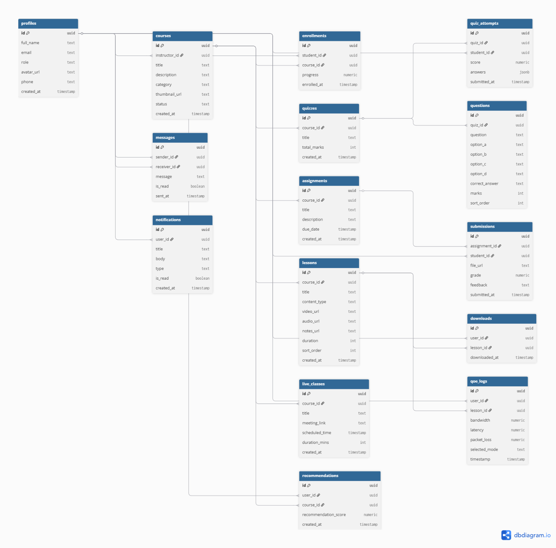

3.1 Relationships Summary
Foreign Key | References
courses.instructor_id | → profiles.id (many courses to one instructor)
lessons.course_id | → courses.id (many lessons to one course)
enrollments.student_id | → profiles.id
enrollments.course_id | → courses.id
quizzes.course_id | → courses.id
questions.quiz_id | → quizzes.id
quiz_attempts.quiz_id | → quizzes.id
quiz_attempts.student_id | → profiles.id
assignments.course_id | → courses.id
submissions.assignment_id | → assignments.id
submissions.student_id | → profiles.id
live_classes.course_id | → courses.id
downloads.user_id | → profiles.id
downloads.lesson_id | → lessons.id
qoe_logs.user_id | → profiles.id
qoe_logs.lesson_id | → lessons.id
recommendations.user_id | → profiles.id
recommendations.course_id | → courses.id
messages.sender_id | → profiles.id
messages.receiver_id | → profiles.id
notifications.user_id | → profiles.id

4. Database Implementation
The EduStream database is implemented on Supabase (PostgreSQL 15). All 15 tables use UUID primary keys generated by uuid_generate_v4() and TIMESTAMPTZ for timezone-aware timestamps. Foreign keys are declared with ON DELETE CASCADE where child records should not outlive their parent.

4.1 Table Schemas

Table: profiles
Column | Type | Constraint | Description
id | UUID | PK, FK auth.users | Mirrors the Supabase Auth user ID
full_name | TEXT |  | User display name
email | TEXT | UNIQUE NOT NULL | Copied from auth on registration
role | TEXT | CHECK | student | instructor | admin
avatar_url | TEXT |  | Public URL in profile-images bucket
phone | TEXT |  | Optional contact number
created_at | TIMESTAMPTZ | NOT NULL DEFAULT | Auto-set on insert

Table: courses
Column | Type | Constraint | Description
id | UUID | PK | Auto-generated UUID
instructor_id | UUID | FK profiles | Course owner
title | TEXT | NOT NULL | Course title
description | TEXT |  | Full description
category | TEXT |  | Faculty or subject area
thumbnail_url | TEXT |  | Public URL in thumbnails bucket
status | TEXT | CHECK | draft | published | archived
created_at | TIMESTAMPTZ | NOT NULL DEFAULT | Auto-set on insert

Table: lessons
Column | Type | Constraint | Description
id | UUID | PK | Auto-generated UUID
course_id | UUID | FK courses | Parent course
title | TEXT | NOT NULL | Lesson title
content_type | TEXT | CHECK | video | audio | text | mixed
video_url | TEXT |  | Path in course-videos bucket
audio_url | TEXT |  | Path in course-audio bucket
notes_url | TEXT |  | Path in course-notes bucket
duration | INTEGER |  | Duration in seconds
sort_order | INTEGER | NOT NULL DEFAULT | Controls lesson sequence
created_at | TIMESTAMPTZ | NOT NULL DEFAULT | Auto-set on insert

Table: enrollments
Column | Type | Constraint | Description
id | UUID | PK | Auto-generated UUID
student_id | UUID | FK profiles | Enrolled student
course_id | UUID | FK courses | Target course
progress | NUMERIC | CHECK 0–100 | Completion percentage
enrolled_at | TIMESTAMPTZ | NOT NULL DEFAULT | Enrollment timestamp
 |  | UNIQUE(student_id, course_id) | Prevents duplicate enrollments

Table: quizzes
Column | Type | Constraint | Description
id | UUID | PK | Auto-generated UUID
course_id | UUID | FK courses | Parent course
title | TEXT | NOT NULL | Quiz title
total_marks | INTEGER |  | Maximum marks available
created_at | TIMESTAMPTZ | NOT NULL DEFAULT | Auto-set on insert

Table: questions
Column | Type | Constraint | Description
id | UUID | PK | Auto-generated UUID
quiz_id | UUID | FK quizzes | Parent quiz
question | TEXT | NOT NULL | Question text
option_a | TEXT |  | Choice A
option_b | TEXT |  | Choice B
option_c | TEXT |  | Choice C
option_d | TEXT |  | Choice D
correct_answer | TEXT | CHECK | a | b | c | d
marks | INTEGER |  | Marks for this question
sort_order | INTEGER |  | Question display order

Table: quiz_attempts
Column | Type | Constraint | Description
id | UUID | PK | Auto-generated UUID
quiz_id | UUID | FK quizzes | Quiz attempted
student_id | UUID | FK profiles | Student who attempted
score | NUMERIC |  | Score achieved
answers | JSONB |  | Full answer log as JSON
submitted_at | TIMESTAMPTZ | NOT NULL DEFAULT | Submission timestamp

Table: assignments
Column | Type | Constraint | Description
id | UUID | PK | Auto-generated UUID
course_id | UUID | FK courses | Parent course
title | TEXT | NOT NULL | Assignment title
description | TEXT |  | Task description
due_date | TIMESTAMPTZ |  | Submission deadline
created_at | TIMESTAMPTZ | NOT NULL DEFAULT | Auto-set on insert

Table: submissions
Column | Type | Constraint | Description
id | UUID | PK | Auto-generated UUID
assignment_id | UUID | FK assignments | Parent assignment
student_id | UUID | FK profiles | Submitting student
file_url | TEXT |  | Path in assignments bucket
grade | NUMERIC |  | Instructor grade
feedback | TEXT |  | Instructor feedback
submitted_at | TIMESTAMPTZ | NOT NULL DEFAULT | Submission timestamp

Table: live_classes
Column | Type | Constraint | Description
id | UUID | PK | Auto-generated UUID
course_id | UUID | FK courses | Parent course
title | TEXT | NOT NULL | Session title
meeting_link | TEXT |  | Video call URL
scheduled_time | TIMESTAMPTZ |  | Session start time
duration_mins | INTEGER |  | Expected duration
created_at | TIMESTAMPTZ | NOT NULL DEFAULT | Auto-set on insert

Table: downloads
Column | Type | Constraint | Description
id | UUID | PK | Auto-generated UUID
user_id | UUID | FK profiles | User who downloaded
lesson_id | UUID | FK lessons | Downloaded lesson
downloaded_at | TIMESTAMPTZ | NOT NULL DEFAULT | Download timestamp

Table: qoe_logs
Column | Type | Constraint | Description
id | UUID | PK | Auto-generated UUID
user_id | UUID | FK profiles | User being monitored
lesson_id | UUID | FK lessons | Lesson being played
bandwidth | NUMERIC |  | Measured bandwidth (kbps)
latency | NUMERIC |  | Round-trip latency (ms)
packet_loss | NUMERIC |  | Packet loss (%)
selected_mode | TEXT | CHECK | hd_video | sd_video | audio_only | text
timestamp | TIMESTAMPTZ | NOT NULL DEFAULT | When adaptation occurred

Table: recommendations
Column | Type | Constraint | Description
id | UUID | PK | Auto-generated UUID
user_id | UUID | FK profiles | Target student
course_id | UUID | FK courses | Recommended course
recommendation_score | NUMERIC |  | Score from 0 to 1
created_at | TIMESTAMPTZ | NOT NULL DEFAULT | Auto-set on insert

Table: messages
Column | Type | Constraint | Description
id | UUID | PK | Auto-generated UUID
sender_id | UUID | FK profiles | Message author
receiver_id | UUID | FK profiles | Message recipient
message | TEXT | NOT NULL | Message body
is_read | BOOLEAN | DEFAULT FALSE | Read receipt
sent_at | TIMESTAMPTZ | NOT NULL DEFAULT | Send timestamp

Table: notifications
Column | Type | Constraint | Description
id | UUID | PK | Auto-generated UUID
user_id | UUID | FK profiles | Recipient user
title | TEXT | NOT NULL | Notification headline
body | TEXT |  | Extended text
type | TEXT | CHECK | assignment | live_class | enrollment | quiz | system
is_read | BOOLEAN | DEFAULT FALSE | Read state
created_at | TIMESTAMPTZ | NOT NULL DEFAULT | Creation timestamp

4.2 Indexes
Twenty-two indexes are created across all tables for query performance:
- courses: instructor_id, status, category
- lessons: course_id, sort_order
- enrollments: student_id, course_id (unique composite)
- qoe_logs: user_id, timestamp DESC
- messages: sender_id, receiver_id, sent_at DESC
- notifications: user_id, (user_id, is_read) WHERE is_read = FALSE
- All foreign key columns across every table

4.3 Automated Triggers
Four PostgreSQL trigger functions automate side effects:

Trigger | Behaviour
handle_new_user | AFTER INSERT on auth.users – creates a profile row automatically on every registration
notify_on_enrollment | AFTER INSERT on enrollments – sends an Enrollment Confirmed notification to the student
notify_on_assignment | AFTER INSERT on assignments – fans out notifications to all enrolled students
notify_on_live_class | AFTER INSERT on live_classes – fans out schedule notifications to enrolled students

4.4 Row Level Security
Row Level Security (RLS) is enabled on all 15 tables. A helper function get_my_role() reads the user’s role from profiles using auth.uid() and is called inside policy conditions. Key rules:
- Students can only access their own enrollments, submissions, downloads, quiz attempts, and QoE logs.
- Instructors can manage only courses, lessons, quizzes, assignments, and live classes they own.
- Published courses are publicly readable; draft courses are visible only to their instructor.
- Messages are readable only by the sender and receiver.
- Admins bypass all restrictions through a universal policy on every table.

4.5 Screenshots – Database Implementation

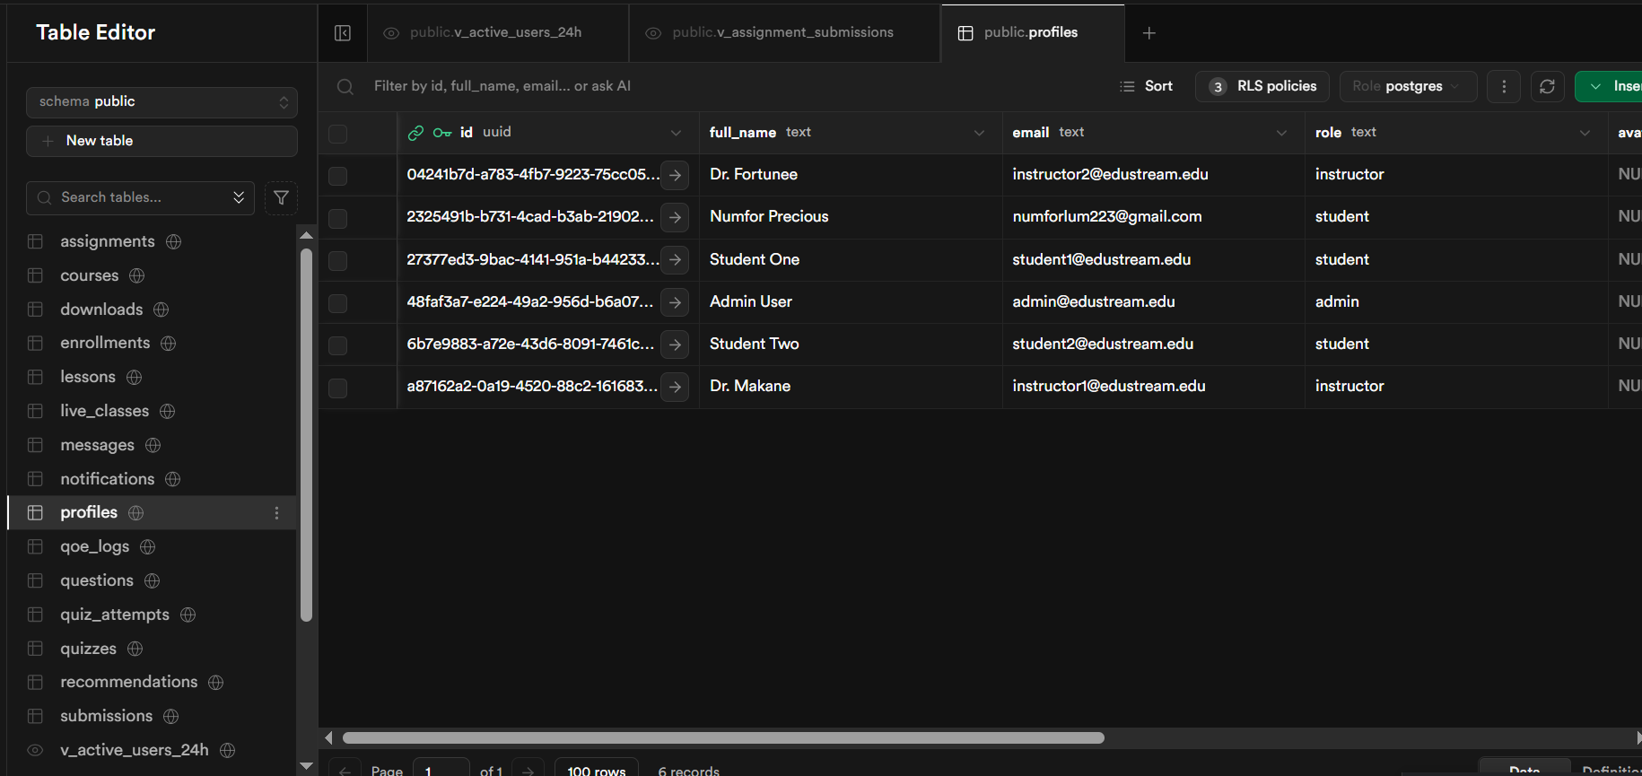

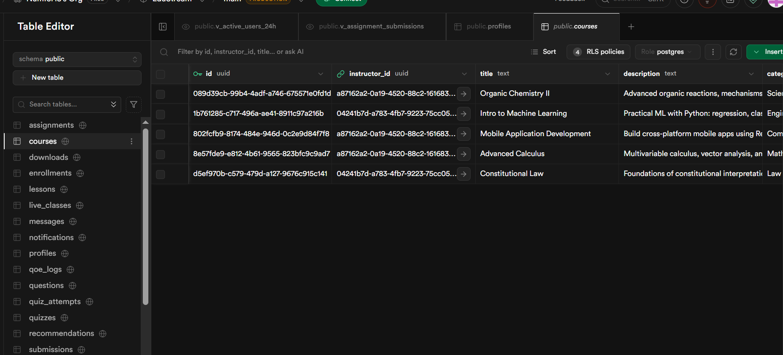
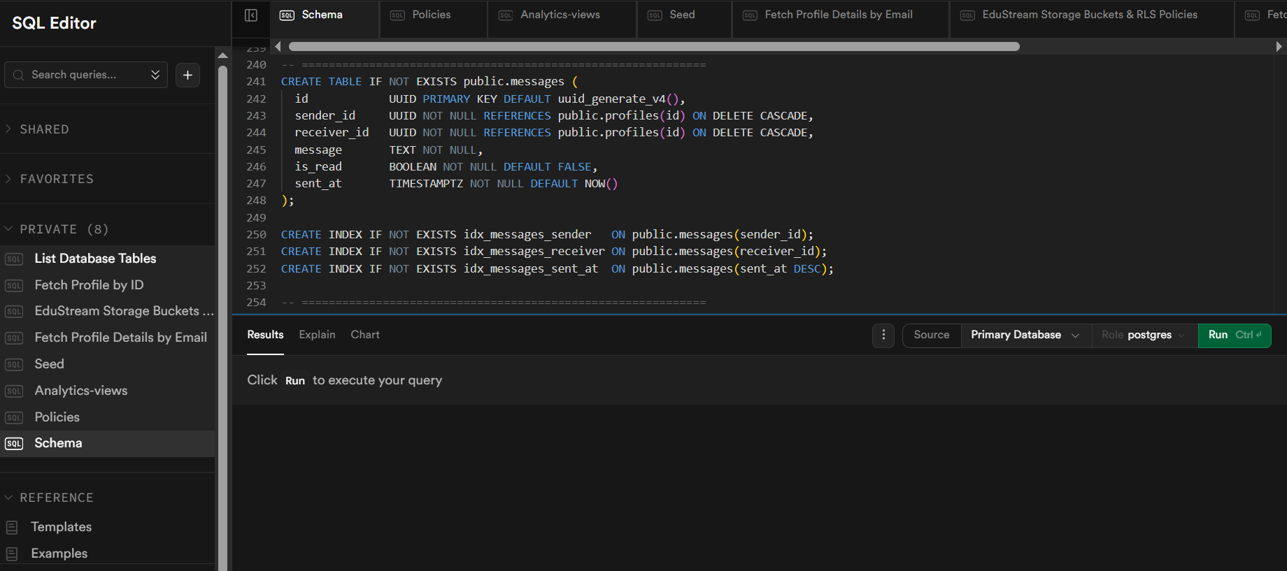

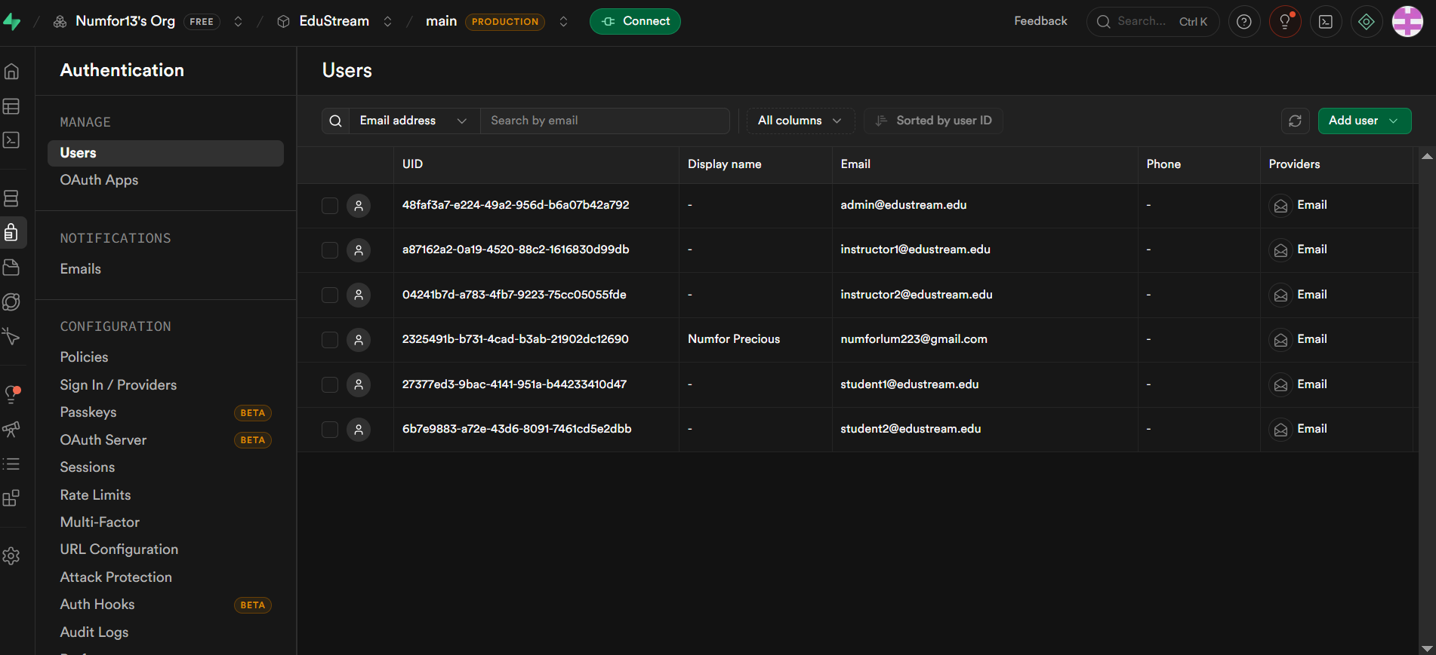

5. Backend Implementation
The EduStream backend is fully serverless, powered by Supabase. The Expo React Native frontend communicates directly with Supabase through the @supabase/supabase-js SDK. There is no custom middleware server; security is enforced entirely at the database level via RLS.

5.1 Technology Stack
Component | Technology
Database | Supabase (PostgreSQL 15)
Auth Provider | Supabase Auth (email/password + JWT)
Frontend | Expo React Native (TypeScript)
Session Storage | expo-secure-store (hardware keychain on device)
Real-time | Supabase Realtime (WebSocket channels)
File Storage | Supabase Storage (S3-compatible, 6 buckets)
SDK | @supabase/supabase-js v2

5.2 Client Library Files
File | Purpose
src/lib/supabase.ts | Supabase client singleton with SecureStore session adapter
src/lib/services.ts | 11 typed service objects covering all domain entities (CRUD)
src/lib/storage.ts | File upload, signed URL generation, and delete helpers
src/hooks/useAuth.ts | Auth hook: session, profile, signIn, signUp, signOut, updateProfile
src/navigation/RootNavigator.tsx | Session-aware navigator routing users by role on app launch

5.3 Service Layer
The services.ts file exports 11 service objects, each covering one domain entity:

Service | Methods
CourseService | list(), get(), listMine(), create(), update(), remove()
LessonService | listByCourse(), create(), update(), remove()
EnrollmentService | enroll(), getMyCourses(), updateProgress(), isEnrolled()
QuizService | listByCourse(), submitAttempt(), getMyAttempts()
AssignmentService | listByCourse(), create(), submit(), gradeSubmission(), getSubmissions()
LiveClassService | listByCourse(), getUpcoming(), create()
DownloadService | markDownloaded(), getMyDownloads()
QoEService | log(), selectMode(), getHistory()
RecommendationService | getForUser(), upsert()
MessageService | getConversation(), send(), markRead(), subscribeToConversation()
NotificationService | getMyNotifications(), markRead(), markAllRead(), subscribeToNotifications()

5.4 Storage Buckets
Bucket | Visibility / Limit / MIME / Purpose
profile-images | Public – 5 MB – JPEG, PNG, WebP – avatar photos
thumbnails | Public – 5 MB – JPEG, PNG, WebP – course cover images
course-videos | Private – 2 GB – MP4, WebM – video lessons
course-audio | Private – 500 MB – MP3, OGG – audio lessons
course-notes | Private – 50 MB – PDF – downloadable notes
assignments | Private – 100 MB – PDF, ZIP – student submissions

5.5 Screenshots – Backend Implementation

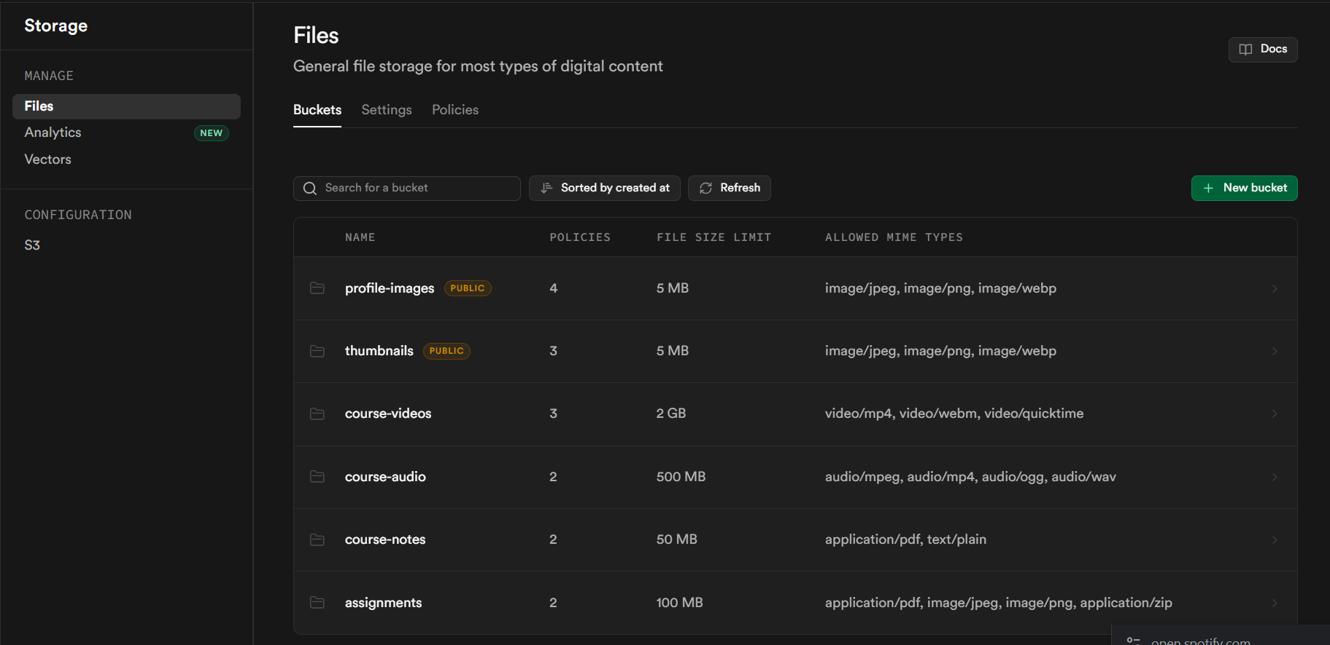

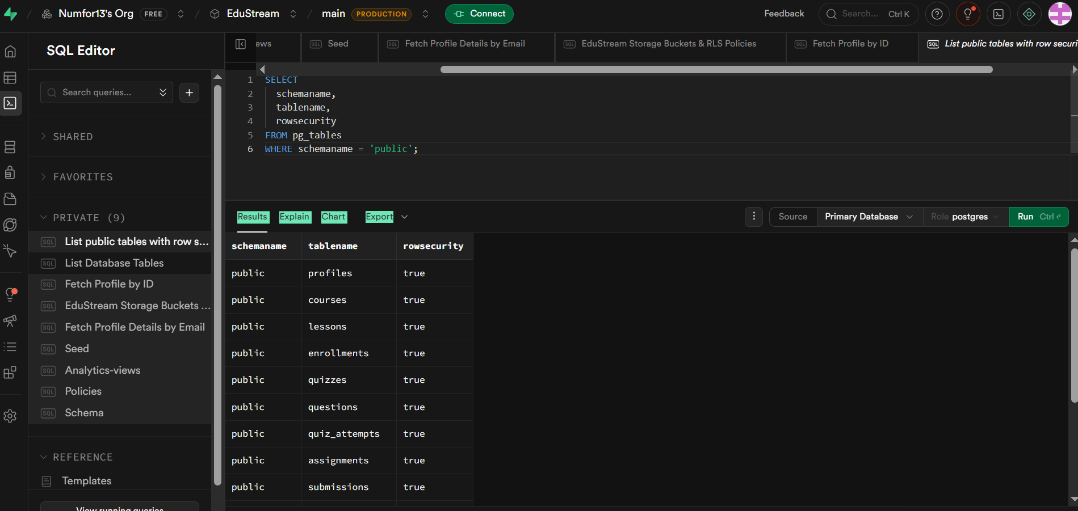

6. Connecting Database to Backend
This section documents how the Supabase database is connected to the Expo React Native frontend and how each screen integrates with the backend services.

6.1 Client Initialisation
The Supabase client is configured once in src/lib/supabase.ts and imported throughout the application. Environment variables EXPO_PUBLIC_SUPABASE_URL and EXPO_PUBLIC_SUPABASE_ANON_KEY are read from a .env file at the project root.

Environment Variable | Source
EXPO_PUBLIC_SUPABASE_URL | Project URL from Supabase Settings → API
EXPO_PUBLIC_SUPABASE_ANON_KEY | Anon public key from Supabase Settings → API

6.2 Authentication Integration
The useAuth hook manages the full authentication lifecycle. On app launch it calls getSession() to restore any stored session. It subscribes to onAuthStateChange to keep state synchronised. The RootNavigator reads the session to route users to the correct tab shell without passing through login screens again.

Step | Mechanism
Registration | signUp() with email, password, fullName, role in options.data
Login | signInWithPassword() – returns JWT stored in expo-secure-store
Session Recovery | getSession() called on app launch
Token Refresh | Automatic via autoRefreshToken: true
Logout | signOut() clears session and resets navigation to Welcome screen
Role Routing | session.user.user_metadata.role – used by RootNavigator to route to StudentTabs, InstructorTabs, or AdminTabs

6.3 Screen Integration Examples
The following table shows how each screen connects to the backend:

Screen | Backend Integration
Student Dashboard | Loads enrollments, recommendations, and unread notifications in parallel using Promise.all(). Subscribes to real-time notifications channel.
Course List | Calls CourseService.list() on mount. Filters by category on user selection.
Learning Screen | Loads lesson data, then runs a 30-second QoE measurement interval calling QoEService.log() and updating playback mode adaptively.
Assignments Screen | Calls AssignmentService.listByCourse(courseId). Uploads submission files via StorageService before calling AssignmentService.submit().
Live Classes Screen | Calls LiveClassService.listByCourse(courseId) to display upcoming sessions.
Messages Screen | Loads conversation via MessageService.getConversation(). Subscribes to real-time INSERT events for instant delivery without refresh.
Calendar Screen | Combines assignments and live_classes queries for enrolled course IDs using supabase.from().in() filter.
Instructor Dashboard | Loads instructor’s own courses via CourseService.listMine(profile.id).
Analytics Screen | Queries six Supabase analytics views (v_course_completion, v_avg_qoe, v_mode_distribution, etc.) created in 05_analytics_views.sql.

6.4 Adaptive QoE Connection
The QoE system connects frontend network measurement to the database as follows:
- Every 30 seconds during lesson playback, the app measures bandwidth, latency, and packet loss using NetInfo and a lightweight ping.
- QoEService.selectMode() runs client-side to pick the appropriate delivery mode (hd_video, sd_video, audio_only, or text).
- If the mode changes, the media player switches immediately without a page reload.
- QoEService.log() inserts the measurement and selected mode into qoe_logs in Supabase.
- The QoE Monitoring Screen and Analytics Screen query qoe_logs history to display trends.

6.5 Real-time Connection
Two Supabase Realtime channels are maintained while users are active:
- Messages channel: subscribes to INSERT events on the messages table filtered by receiver_id = auth.uid(). New messages appear instantly in the MessagesScreen.
- Notifications channel: subscribes to INSERT events on the notifications table filtered by user_id = auth.uid(). Database triggers create notifications automatically when assignments or live classes are added.
- Both channels are cleaned up via supabase.removeChannel() when the screen unmounts, preventing memory leaks.

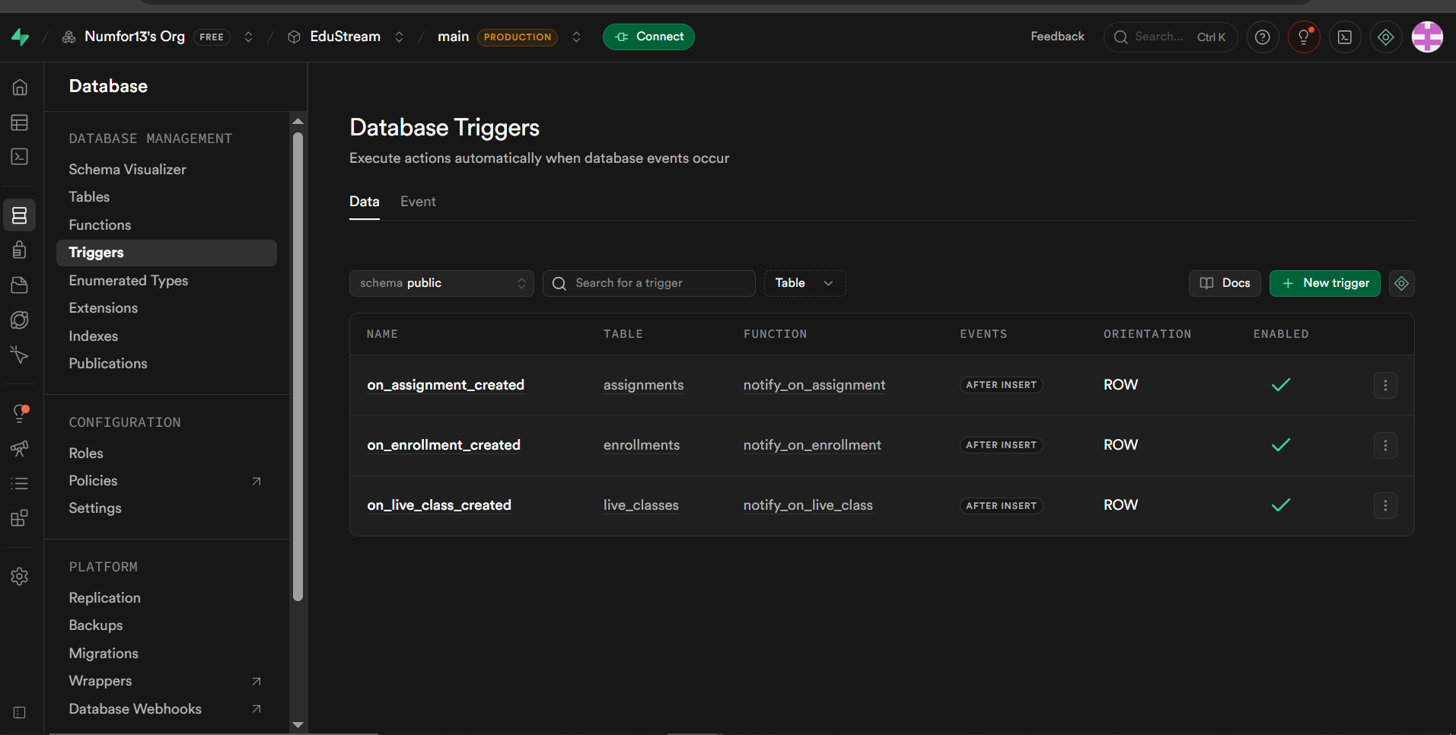

6.6 Deployment Steps
To connect the database to the application:
- Create a Supabase project at supabase.com and select a region.
- Run 01_schema.sql in the Supabase SQL Editor to create all 15 tables.
- Run 02_rls_policies.sql to enable RLS and apply all security policies.
- Run 03_storage.sql to create the 6 storage buckets and their policies.
- Run 05_analytics_views.sql to create the 6 analytics views.
- Copy the Project URL and anon key from Supabase Settings → API into a .env file.
- Run: npx expo install @supabase/supabase-js @react-native-async-storage/async-storage expo-secure-store expo-file-system react-native-url-polyfill base-64
- Start the app with npx expo start and verify login, course listing, and QoE logging.
- A demo video will be added to this file to show connections

6 Conclusion
The combination of React Native, Supabase, and PostgreSQL was well suited for the development of the adaptive e-learning platform because it provided a modern, scalable, and efficient full-stack solution.
React Native enabled the development of a cross-platform mobile application using a single codebase, reducing development time and maintenance costs while delivering a consistent user experience on both Android and iOS devices. Its component-based architecture and extensive ecosystem also made it easier to build a responsive and professional user interface.
Supabase served as the backend platform by offering integrated services such as authentication, database management, API generation, and row-level security. These built-in features significantly reduced backend complexity and accelerated development, allowing the team to focus on implementing the application’s core functionality rather than infrastructure.
PostgreSQL, the database engine underlying Supabase, provided a robust relational database system with strong support for data integrity, structured relationships, indexing, and complex queries. It was particularly appropriate for managing interconnected entities such as users, courses, enrollments, learning content, and progress records while ensuring reliability and consistency.
Together, these technologies enabled secure user authentication, efficient data storage and retrieval, seamless frontend-backend communication, and the flexibility to support future enhancements. As a result, they formed a reliable and production-ready technology stack for implementing the adaptive e-learning platform.

